Research Abstracts

Alpher, Elliott J., and Kirsch, Daniel L. Traumatic brain injury and full body reflex sympathetic dystrophy patient treated with cranial electrotherapy stimulation. American Journal of Pain Management, 8(4):124-128, 1998. Presented at the Ninth Annual Clinical Meeting of the American Academy of Pain Management, Atlanta, Georgia, September, 1998.
This is a case report of WHH, a 60 year old male with an intracranial traumatic brain injury (TBI) and full body reflex sympathetic dystrophy (RSD). In spite of severe disabilities of his brain and body, WHH continues to serve his country in his position on the Executive Staff of the President’s Committee on Employment of People with Disabilities. Daily 20 minute CES treatments provide satisfactory pain relief for WHH to complete his tasks and enjoy a relatively higher quality of life than he was able to have with drugs alone.
Prior to CES, WHH has been prescribed numerous medications including Prozac 20 mg q.i.d., Catapres Tab 20 mg q.d., Effexor 100 mg in AM and 50 mg at bedtime, Levo-Dromoran 1 mg b.i.d., Balofen 10 mg split AM and PM, Risperdal 7.5 mg at bedtime, Kolopin 0.5 mg one tab three to four times per day as needed, C-Dextromthrph 60 mg t.i.d. and Fentanyl patches for four years. This regime did little to reduce his whole body chronic intense critical pain and burning. Nor did it relieve his difficulty sleeping. Standard milliampere transcutaneous electrical nerve stimulation (TENS) did not help. WHH claims these treatments made him worse and is concerned about the short and long term side effects the drugs have on his ability to function.
Following CES treatment WHH exhibited marked relaxation, with a reduced anxiety level and a significantly enhanced pain threshold. Based on these positive results he was prescribed daily 20 minute CES treatments via ear clip electrodes. WHH credits the CES treatment for allowing him to return to work, and for improving his family and social life. Prior to CES he claimed that “life was not worth living to the degree that suicide was an attractive option.” He found this treatment provided him a moderate improvement of 50 - 74% relief from his pain, anxiety, depression, headaches, and muscle tension, and a marked improvement of 75 - 99% in his insomnia.
A single CES treatment lasts for 6 to 8 hours, allowing him to get through the day, then the pain gradually returns, but never to his pre-CES pain levels prior to the next CES treatment. In his own words, “The Alpha-Stim 100 has given me short term relief from my pain levels that medications have not been able to accomplish. While the relief periods may only be for 8 hours or so, these near pain-free hours allow my body to recycle itself, granting me an improved quality of life. Without the Alpha-Stim 100, the constant ‘level 10’ debilitating pain levels leave me with no physical or emotional reserves to carry on daily life. The Alpha-Stim 100 has no side effects, whereas my medicines have profound, crippling and lasting side effects that have impaired my bowel and colon. These impairments can not be reversed.” On a zero (no pain) to 10 (maximum pain) scale, Mr. Hulley says CES reduces his pain level from a 10 to a 3 which he describes as “the difference between standing on a busy street in New York at 5 PM and fly fishing on a tranquil creek.” He added “CES provides me with a measure of pain relief that brings me back from the depth of despair and gives me a wedge of hope.”
CES reduces his pain level to a point where he can perform his daily exercise routine. He is also able to rest better at night which he credits as creating a “positive emotional and physical self-environment.” He now feels more rested in the morning. At present he is able to work 30 to 40 hours per week, up from a maximum of 15 hours prior to CES.
Following CES, his medication has been reduced to Prozac 10 mg q.d., Catapres Tab 0.1 mg b.i.d., Effexor 50 mg AM and 25 mg PM, Levo-Dromoran 1 mg b.i.d., Restoril 7.5 mg at bedtime, Kolopin p.r.n., and Neurontin 400 mg p.r.n.
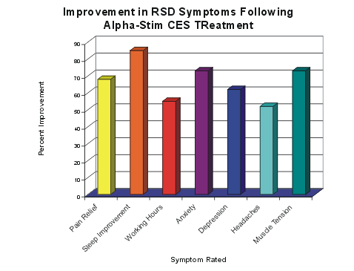
The graph shows his remarkable improvement in seven areas of his former major complaints, and indicates that the improvements ranged from 52% to 83% at the time the journal article went to press.

