Research Abstracts
Boswell, NS, & Bauer, W. Noninvasive electrical stimulation for the treatment of radiotherapy side effects. American Journal of Electromedicine, 2(3), 1985. Presented at the International Conference on Head and Neck Cancer, Baltimore, Maryland, July, 1984.
Pain, dry mouth, and dysphagia are still present in nearly every patient undergoing radiotherapy, and interruption of treatments for rest periods is still the rule for a large percentage of patients. This is an original investigation using the Alpha-Stim for the treatment and prevention of radiation side effects in 10 male patients undergoing up to 22 radiation therapy sessions with a 4 megavolt cobalt linear accelerator for squamous cell carcinoma of the oropharynx, and 13 matched control subjects at the Veterans Administration Medical Center in Cleveland, Ohio. Once Alpha-Stim therapy was initiated using 50 to 500 µA at 0.5 Hz, within 4 hours of radiation, no interruption of radiotherapy was necessary. In addition those having symptoms from radiation before Alpha-Stim was begun were markedly palliated. All patients were treated until their symptoms were reduced to zero or close to it. One year follow-up indicates that patients remain pain free if there is no return of tumor. In contrast, 9 of the 13 patients in the control group had radiation interrupted because of radiotherapy side-effects. Pain with mucositis was the most common complaint in the control group.
The authors also address the question of effects of electrical stimulation on the tumor itself, "In the low frequency and low energy range, which we are using, there is a growing literature of tumor regression and reversibility of tumor cells." They warn, "It should be emphasized that the term electricity is generic. Just as digitalis and codeine are both pills, they are totally different in effect and action." Accordingly, future research must carefully define the electrical characteristics and devices which are used.
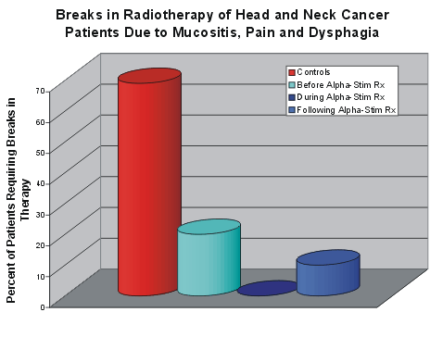
The graph shows that 69% of the control patients had therapy interruptions due to negative side effects from the radiation, no patient had a break from radiation therapy while also receiving Alpha-Stim microcurrent stimulation, and only one patient had to have a break from treatment after Alpha-Stim treatment had ceased and was no longer available.

