Research Abstracts
Brovar, Alan. Cocaine Detoxification with cranial electrotherapy stimulation (CES): A preliminary appraisal. International Electromedicine Institute Newsletter, 1(4), July/Aug, 1984. Also in Brain/Mind Bulletin, 9(14), August, 1984.
25 consecutive admissions to a drug abuse treatment hospital who qualified for DSM III diagnosis of cocaine abuse were included in the study. Patients were alternately assigned to a control group (N = 12), and Alpha-Stim CES treatment (N =13), of which only 5 accepted while 8 refused. CES was given for 20 minutes twice a day for the 5 day inpatient treatment program. All 5 (100%) of the CES patients completed detoxification, compared with 75% of the other 20. All 5 (100%) of the CES patients completed the treatment program, compared with 63% of the CES refusers and 67% of the other 12 controls. A follow-up of the 3 groups from 6 to 8 months later showed that no CES patients had returned for treatment, while 50% of the CES refusers and 39% of the controls had recidivated. One of the latter had died of overdose.
The role of CES in the treatment of chemical dependency is of great interest since anxiety and insomnia are frequently present in the early stages of recovery and are a common precursor to relapse. The authors concluded that CES facilitated patient retention in a hospital detoxification and rehabilitation program for cocaine dependent persons. No side effects were reported.
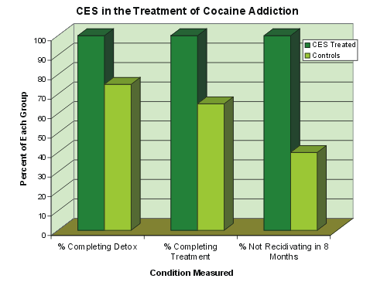
The graph shows the relative performance of the CES treated group compared with the controls, in the three areas measured: Completion of detoxification, completion of the treatment program, and not returning for additional treatment in the six to eight months follow-up period.

