Research Abstracts
Frick, Ava. Microcurrent electrical therapy heals a recalcitrant wound in a horse. Journal of Equine Veterinary Science 25(11): 418-422, 2005. Presented at Western Veterinary Conference, Las Vegas, Nevada,
February 24, 2005.
This is the first documented report using Alpha-Stim MET to heal a wound in a horse. The patient is a two-year-old AQH mare that had fallen on top of a T-post, creating a very large wound to her right rear quarter. The tuber coxae had been shattered. The damaged bone was surgically removed with the remaining wound sutured as much as possible. One month of flushing and treating topically ensued with slow progress, and the wound became infected.
MET was initiated on March 8, 2004 using the Alpha-Stim PPM. Four AS-Trode brand silver electrodes were placed around the wound to encompass the injury site. At that time the total length of the wound was 18 inches cranial to caudal with the open lesion being 8 inches in length.
The Alpha-Stim PPM is preset at 0.5 Hz. To induce healing, the current was set at 100 microamperes. The horse was treated seven days per week, 24 hours per day for three weeks. By choice the mare did not lie down on the affected side, so there was no problems with the device attachment. The device and electrodes were checked daily, changing the 9-volt battery and AS-Trodes, along with shaving the attachment site as required.
Figures 1 and 2 show the horse at the initiation of treatment, on March 8, 2004. Figure 2 indicates the placement of the electrodes. Figures 3, and 4, taken after ten days of MET show substantial healing and a clean wound. Figure 5 was taken after MET treatment was completed on March 30, after a total of three weeks of daily treatment. Figure 6, the final picture were taken July 1, 2004 when the horse was returned to training.
In this case, microcurrent electrical therapy proved to be a safe and effective means for reducing the healing time and bacterial contamination of a large wound and may have saved the horse’s life. This therapy can be done in an animal hospital or at home with the appropriate instructions from the veterinarian. Since the device is reusable after the wound heals, it is an economical approach that may prove superior to other conventional long-term wound management measures.

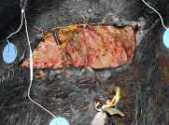 | 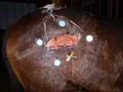 | 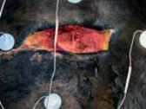
Figure 1. 3-8-2004  One month post wound, at  Initiation of MET therapy. | Figure 2. 3-8-2004  At initiation of MET therapy to show proportion of wound. Note also the lack of skin available to cover wound site. | Figure 3. 3-18-2004  Ten days of MET showing substantial healing and a clean wound.
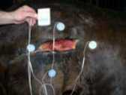 | 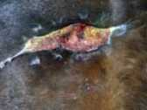 | 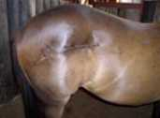
Figure 4. 3-18-2004  Ten days of MET showing the device used. | Figure 5. 3-30-2004  After three weeks of MET treatment was completed. | Figure 6. 7-1-2004  The horse was returned to training.

