Research Abstracts
Lerner, Fred N, & Kirsch, Daniel L. A doubleblind comparative study of microstimulation and placebo effect in short term treatment of the chronic back pain patient. Journal of the American Chiropractic Association, 15(11):101-106, 1981.
This was the first published report introducing bioconductive therapy using the Alpha-Stim when it was still a prototype. 40 subjects were selected from the first author’s practice, from 19 to 63 years old (mean of 38.3 years), 58% females, with chronic (more than 12 months), persistent back pain with few, if any, remissions. 25 (63%) had low back pain, 15 (37%) had pain above T7, 31 (78%) had headaches, and 26 (65%) had extremity pain. After providing informed consent, they were divided into 2 matched groups based on a 2 week pre-study analyses of hourly 0 - 5 pain evaluation charts: one group received Alpha-Stim stimulation, and the other placebo. The same hourly pain charts were used during the actual 2 week treatment period, 2 weeks after treatment, and again, for an additional 2 weeks following a washout period of 2 months. Treatment was done at 16 measured low conductive sites following dermatomes derived from positive orthopedic and neurologic test findings (bioconductive therapy). The subjects in the Alpha-Stim group experienced an average pain reduction 37.26% greater than the placebo group. The 2 month followup showed a significant difference: 75.22% pain reduction in the real, compared to only 6.30% pain reduction in the placebo group. The placebo subjects may have experienced some therapeutic effect from the measurement current. No side effects were reported.
Notes: This study won a scientific research award from the American Chiropractic Association (ACA). This study has been plagiarized as marketing materials for the Electro-Acuscope two years after it was published. In the plagiarized version, only the authors names and the device used was changed.
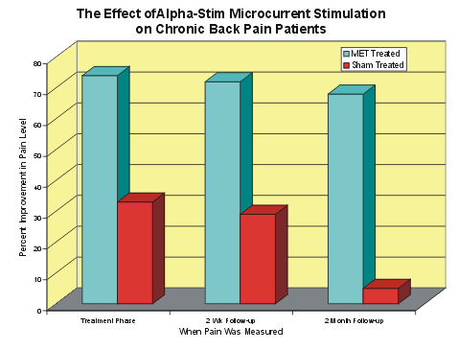

The graph shows that the sham treated group improved up to 32.5% at the two week follow-up before beginning a downhill course which continued through the two follow-up periods. Their initial improvement may have been due to pressure cupuncture, since the electrodes were pushed firmly against the skin during sham treatment. The treated patients had a 74% improvement immedicately after treatment, 72% improvement on two week follow-up, and were still at a 67% improvement two months following the short treatment, compared with the sham treated patients who were showing only 5% improvement at that time.

