Research Abstracts
Madden, R, & Kirsch, DL. Low intensity electrostimulation improves human learning. American Journal of Electromedicine, 4(2):41-45, 1987. Doctoral dissertation (RM), City University Los Angeles, 95 pages, 1987. Presented at The New Brain Technologies and Accelerated Learning Conference at the University of Hawaii, April, 1987.
103 normal, healthy volunteer subjects without typing skills, responded to recruitment efforts, 21 failed to satisfy the inclusion criteria or declined to participate. Of the remaining 82, 4 did not show up. 78 (29 males and 49 females) completed this double blind study. They were randomly assigned to receive either 1, 20 minute Alpha-Stim CES treatment session (N = 39), or sham treatment (N = 39). The performance measuring device was a computer game called MasterType designed to teach typing skills, while measuring speed and accuracy. A baseline trial was conducted without stimulation. Immediately following the first trial, the subjects received real or sham CES and began the second trial. A total of 4 trials were completed by all subjects. Performance products (PP’s) were obtained by multiplying rate per minute and accuracy scores following the completion of each trial. Prestimulation means of the first 2 trials were calculated as PPt1 (performance product for the first trial). PPt2 represented poststimulation or sham stimulation. The dependent variable was the performance gain score computed by taking the difference between PPt1 and PPt2 performance products represented as PG = PPt2 - PPt1. All t-tests were employed at the 0.01 confidence level. CES subjects improved significantly on the computer task involving psychomotor cognitive skills, with a PP4 - PP2 PG mean of 5.6 ± 2.2, while 12 (30.8%) of the sham patients actually experienced a decrement in performance, and none improved significantly: PP4 - PP2 PG mean of 0.7 ± 2.3. The unexpected decline in performance in some unstimulated subjects suggests a possible fatigue and/or inattention factor which may have gained dominance over the familiarity and practice factors.
The authors concluded that this study demonstrates the efficacy of CES in improving human learning and performance. Normal or learning disabled children might be taught more efficiently under the immediate or residual effects of CES in classroom settings. Others seeking increased alertness, concentration, and performance may also benefit, such as police officers, automobile drivers, air traffic controllers, surgeons, pilots, and athletes. No side effects were reported.
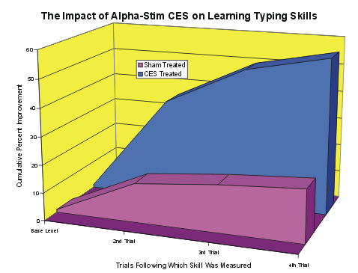

The graph shows the cumulative percent improvement of the two groups over the four performance trials. It shows that those who received 20 minutes of Alpha-Stim CES prior to the learning task, did significantly better than did those who received only sham treatment.

