Research Abstracts
May, Brad, & May, Carole. Pilot project using the Alpha-Stim 100 for drug and alcohol abuse. August, 1993.
14 male volunteers in 2 recovery homes for several days to 7 months received 25, 1 hour Alpha-Stim CES treatments. Multiple Affect Adjective Check List (MAACL) means showed a significant and dramatic decline in the anxiety scores by mid test dropping from 4.07 pretest to 1.00 mid test and 1.00 post test. Depression (3.42 pretest to 0.79 mid and post test) and hostility scores (2.43 pretest to 0.71 mid and post test) were also reduced significantly, while significant increases were seen in self-worth, feeling expression, and capacity for intimate contact. The Beck Depression Inventory dropped from 14.50 pretest to 5.00 midtest to 3.50 post test.
The investigator commented that verbal feedback was equally exciting. One participant said afterwards, “something inside me has shifted and I just know I’m never going to take another drink of alcohol again.” Another said, “I’ve been sober for about 75 days, but it feels like I’ve been sober for years.” No side effects were reported.
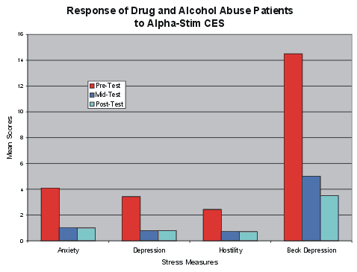

The graph shows that all scores improved significantly over the treatment period. While there were no treatment controls in the study, the recovery home norms were typically much lower or showed no improvement. This material was not provided in the report so was not graphed.

