Research Abstracts
McClure, Mark W., and Morehead, Kenneth. A pilot study of the use of microcurrent stimulation in the treatment of interstitial cystitis. October, 1999.
Six female patients suffering from interstitial cystitis pain were involved in an open clinical pilot study in which they were allowed to stimulate themselves with the self adhesive electrodes of the Alpha-Stim 100 device for one hour a day for 3 weeks at home. The electrodes were placed with one directly over the most painful area at the lower abdomen and the other electrode on the lower back so that a straight line drawn between them would pass through the area of most intense pain.
The first graph shows a 50% reduction in their self rated pain, a significant improvement in their quality of sleep, a greater than 70% improvement in their feeling of well being and a substantial improvement in their self rated overall quality of life following the three weeks of treatment.
In the second graph it can be seen that important improvement occurred on every psychological factor measured, including anxiety, depression, pain related cognitive confusion, their fatigue level and so on.

Figure 1
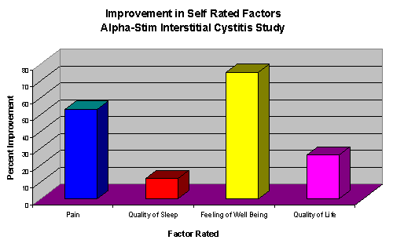

Figure 2

