Research Abstracts
Smith, Ray B, Cranial electrotherapy stimulation in the treatment of stress related cognitive dysfunction, with an eighteen month follow up. Journal of Cognitive Rehabilitation, 17(6):14-18, 1999.
This study compared the effects of 3 randomly assigned CES devices (Alpha-Stim, CES Labs, Liss Stimulator) in the treatment of stress related attention deficit disorder (ADD) in 23 children and adults, 9 males, 14 females, 9 - 56 years old (average 30.96) with an average education level of 10.56 years. All had been diagnosed as having generalized anxiety disorder (61%), and/or depression (45%), and/or dysthymia (17%), with 1) difficulty in focusing when attempting cognitive tasks, difficulty in “connecting” when initially focused on a cognitive task, and 3) once connected, having difficulty remaining on task or tracking it. CES treatments were given daily, 45 minutes per day for 3 weeks. All 3 CES devices were effective based on Duncan’s Range test in significantly (P<.001) reducing depression as measured on the IPAT depression scale (mean of 19.38 8.44 pretest to 13.19 7.00 post test), state and trait anxiety scales of the State Trait Anxiety Inventory (mean state anxiety was reduced from 39.95 11.78 pretest to 29.76 6.99 post test, and the mean trait anxiety was reduced from 43.90 11.31 pretest to 32.19 7.50 post test), and in increasing the Verbal pretest (mean of 99.38 13.20 to post test of 107.50 14.13), Performance (mean of 107.4 15.05 to 126.6 14.2 ), and Full Scale I.Q. scores on the WISC-R or WAIS-R I.Q. tests (mean of 103.2 13.7 to 117.6 14.28). Overall, 18 (86%) of the subjects tested showed improvements in their depression, 18 (86%) in state anxiety, 18 (90%) in trait anxiety, and 100% had an increase in their Full Scale I.Q. scores, 22 (96%) in their Verbal I.Q. scores, and 100% improved their performance I.Q. scores. Several of the adult subjects reported that they felt “mentally normal” for the first time in their lives.
An 18 month follow up found 18 of the original 23 subjects available to return for testing. Overall, they performed as well or better than in the original study. None of the scoring changes in anxiety or depression between post study and follow up testing were found to be significant. The initial Full Scale I.Q. increase held up over the 18 month period while there was a slight, but significant rise in the Verbal I.Q. score (t = 2.37, df = 17, P>.05) and a similar slight, but significant decrease in the Performance I.Q. (t = 3.75, df = 17, P>.01). The author concluded that this study gives strong support for the clinical use of treating stress related cognitive dysfunction in both children and adults.

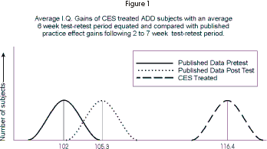
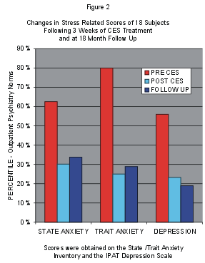 | 