Research Abstracts
Smith, Ray B, & Shiromoto, Frank N. The use of cranial electrotherapy stimulation to block fear perception in phobic patients. Journal of Current Therapeutic Research, 51(2):249-253, 1992.
After achieving Institutional Review Board approval and informed consent, 31 persons responded to public media announcements requesting subjects who had been medically diagnosed as having 1 or more phobias. 25 were females (81%). The age ranged from 26 - 66 (mean of 48.69) with an average length of time since their phobia was diagnosed as 16.33 years (range 1 - 44 years). 65% (N = 20) were on medications, and of these, 60% (N = 12) were taking alprazolam. Each subject served as his/her own control. The authors cited an earlier study that reported internally elicited phobic thoughts produced as much and, at times, greater subjective anxiety, fear, and physiological activity than similar thoughts triggered externally by pictures or verbal statements about phobic objects. The subjects were asked to imagine themselves in their phobic stimulus situation and rate their fear on a 7 point scale. Following 30 minutes of Alpha-Stim CES stimulation, and while the stimulation was still on, they were asked to frighten themselves as before. 1 subject left the study before the program began, citing increased situational anxiety as the reason. 4 subjects, appearing to be elated, rated their end-of-study fear as 0, which was not on the scale. That left a useable N of 26. While 77% (N = 20) rated their fear as moderate to extreme going into the study, 85% (N = 22) rated their fear from very low to none following the CES stimulation (mean of 3.33 ± 1.22 pretest to 1.96 ± 0.76 post test). The results reached significance of P<.0001.
The authors concluded that from their data it appears that CES may be successfully instituted while patients are on medication. By the same measure, CES appears to be equally as effective without supportive medication and might be a useful tool with which to withdraw patients from such medication, should the physician desire. Since CES devices are portable, its use by the patient in most phobic stimulus situations would appear feasible. No negative side effects were reported.
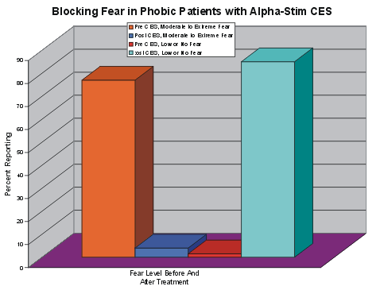

The graph shows that prior to the CES, 77% of the phobic persons rated their achieved fear as moderate to extreme, while following the CES, 85% rated their fear as very low or none.

