Research Abstracts
Voris, Marshall D., and Good, Shirley. Treating sexual offenders using cranial electrotherapy stimulation. Medical Scope Monthly, 3(11):14-18, 1996.
For a period of 6 weeks, 2 groups of convicted male pedophiles controlled by the Dallas Probation Department were treated using relaxation training and Alpha-Stim CES. Individuals were randomly assigned to treatment groups by numbers out of a hat. 2 assumptions were made in this study: 1) anxiety is at the root of much of the deviant behavior, and 2) deviant behavior is an attempt to self-medicate anxiety. Group A consisted of 8 individuals from 24 to 73 years old who received 300 µA CES at 0.5 Hz for 20 minutes. Group B was 7 individuals from 26 to 70 who received 20 minutes of relaxation training which involved a hypnotic-like induction using the Speigal method of eye rotation and eye closure, with focus on breath control. Both groups were treated once weekly for 4 weeks. The State Trait Anxiety Inventory (STAI) using form X to measure trait (constant) anxiety factors was used 1 week before and 1 week after the treatments, along with electromyogram (EMG) measurements as an independent physiological measure and the Sexual Inventory (SI), a questionnaire that asks for information regarding fantasy and behavior relating to deviant and nondeviant activities. The SI is not yet standardized for validity and reliability, but serves a purpose of having a simple pencil/paper report tool. The CES group STAI was reduced from 41.63 pre test to 27.38 post test. The relaxation training group STAI was reduced from 41.29 to 36.86. EMG changes were 8.40 to 3.97 µV in the CES group, and 9.81 to 11.10 µV in the relaxation training group.
These scores must be viewed cautiously due to the small sample size. Nevertheless they do reveal some important findings. Both groups had a similar pre STAI, and both improved significantly (P=.01 for CES group) in their trait anxiety with the clear advantage being demonstrated with CES. The EMG findings, attributable to changes in state anxiety, showed a significant decrease in the CES group while the relaxation group actually exhibited an increase in their muscle tension. The SI also demonstrated less sexual behavior, both normal and deviant, in the CES group, suggesting that CES was effective in lowering sexual behavior/acting out. The author was surprised by the findings between the groups, and believes that this study necessitates more testing in the distinction between state and trait anxiety as it relates to pedophilia. This research began looking at the feasibility of introducing a mechanism for reduction of trait anxiety among pedophiles. CES, according to the results of this study, has accomplished that task very well. No side effects were reported.
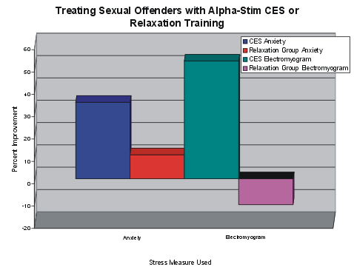
The graph shows that CES was dramatically more effective in improving the anxiety score on the State/Trait Anxiety Inventory than was the relaxation training, and that it also reduced overall muscle tension, while those in the relaxation training group actually ended with more muscle tension.

